Customer Shopping Behavior Analysis

Project Overview
This project analyzed data from 3,900 customer purchases across different product types to understand who our customers are and how they shop. Our main goal was to discover spending habits, what products people like, and how many are using our subscription service. This information will help us make smarter business decisions.

Dataset Summary
- Rows: 3,900
  - Columns: 18
  - Key Features:
    - Customer demographics (Age, Gender, Location, Subscription Status)
    - Purchase details (Item Purchased, Category, Purchase Amount, Season, Size, Color)
    - Shopping behavior (Discount Applied, Promo Code Used, Previous Purchases, Frequency of Purchases, Review Rating, Shipping Type)
  - Missing Data: 37 values in Review Rating column

Exploratory Data Analysis using Python
We began with data preparation and cleaning in Python:

- Data Loading: Imported the dataset using pandas.

- Initial Exploration: Used df.info() to check structure and .describe() for summary statistics.
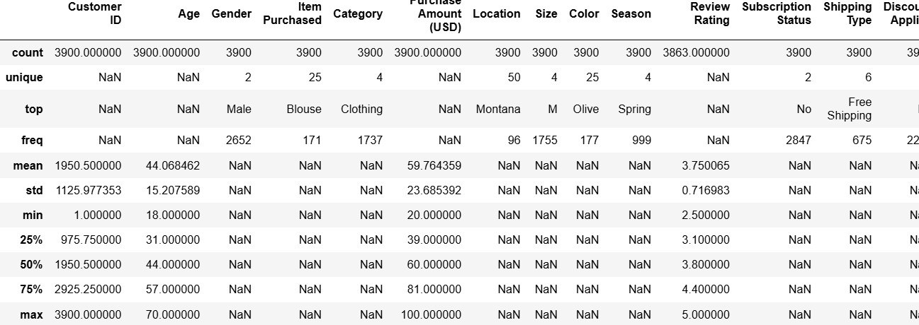

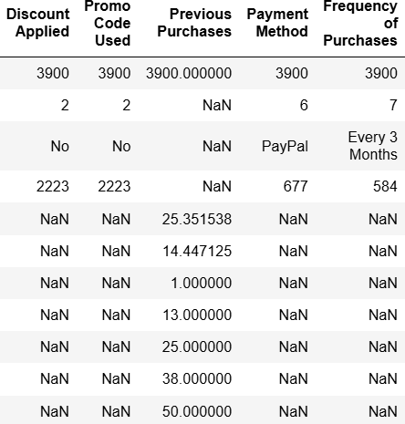

- Missing Data Handling: Checked for null values and imputed missing values in the
Review Rating column using the median rating of each product category.

- Column Standardization: Renamed columns to snake case for better readability and documentation.

- Feature Engineering:

  - Created age_group column by binning customer ages.

  - Created purchase_frequency_days column from purchase data.

- Data Consistency Check: Verified if discount_applied and promo_code_used
were redundant; dropped promo_code_used.

- Database Integration: Connected Python script to PostgreSQL and loaded the cleaned DataFrame into the database for SQL analysis.

Data Analysis using SQL (Business Transactions)
We performed structured analysis in PostgreSQL to answer key business questions:

- Revenue by Gender – Compared total revenue generated by male vs. female customers.

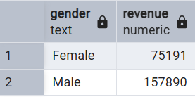

- High-Spending Discount Users – Identified customers who used discounts but still spent above the average purchase amount.
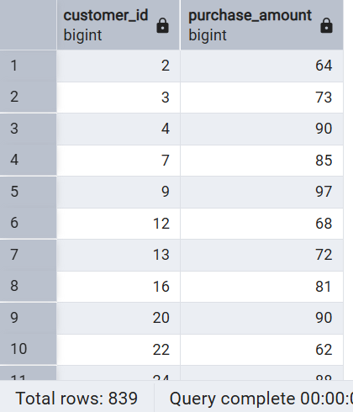

- Top 5 Products by Rating – Found products with the highest average review ratings.

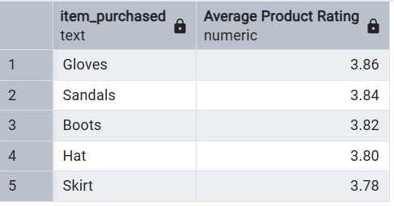

- Shipping Type Comparison – Compared average purchase amounts between Standard and Express shipping.
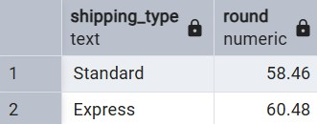

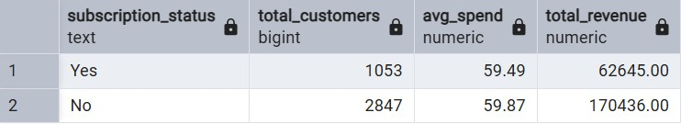
- Subscribers vs. Non-Subscribers – Compared average spend and total revenue across subscription status.

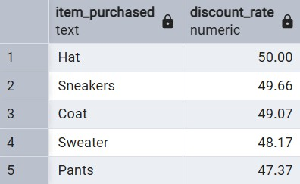
- Discount-Dependent Products – Identified 5 products with the highest percentage of discounted purchases.

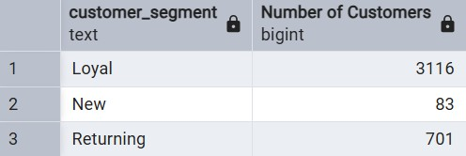
- Customer Segmentation – Classified customers into New, Returning, and Loyal segments based on purchase history.

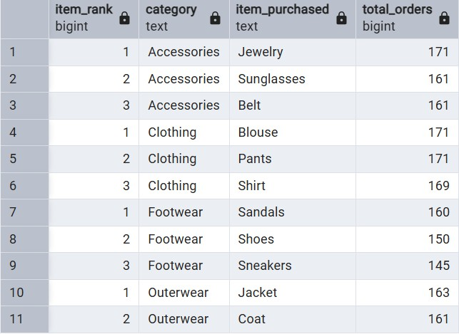
- Top 3 Products per Category – Listed the most purchased products within each category.
- Repeat Buyers & Subscriptions – Checked whether customers with >5 purchases are more likely to subscribe.
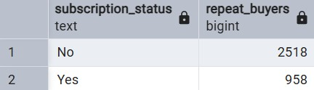
- Revenue by Age Group – Calculated total revenue contribution of each age group.

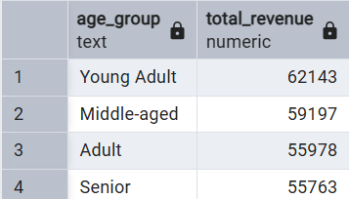

Dashboard in Power BI

Finally, we built an interactive dashboard in Power BI to present insights visually.
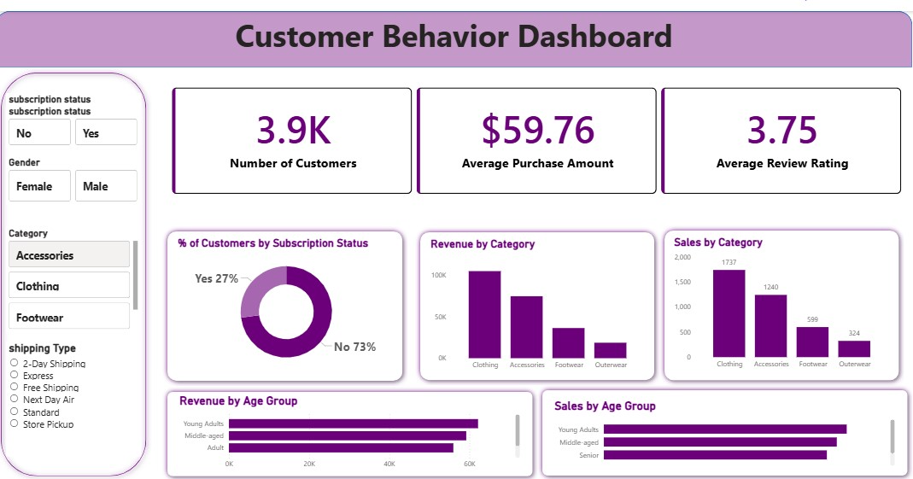

Business Recommendations

- Boost Subscriptions : Given that 73% of customers are not subscribed, we need to promote exclusive benefits and value to encourage sign-ups. We should specifically target our Repeat Buyers who have not yet subscribed, as they are already frequent customers.
- Reward Loyalty : 839 customers are high-spenders who use discounts. We should create a Customer Loyalty Program to reward these and other repeat buyers to solidify their loyalty and move more customers into the "Loyal" segment.
- Review Discount Strategy : Products like Hats and Sneakers rely heavily on discounts. We need to evaluate our discount policy to ensure sales boosts don't excessively hurt profit margins. We should also consider using discounts strategically to push lower-rated or slower-moving items.
- Targeted Marketing :
- Focus marketing campaigns on the Young Adult age group and the Clothing category since they generate the highest revenue and sales.
- Highlight top-rated products like Gloves and Sandals and best-sellers like Blouses in our advertising campaigns.
- Target users who choose Express Shipping, as they have a higher average spend, suggesting they may be less price-sensitive

